AI-Driven Business Innovation: Agricultural Sector Applications

Michael Borck, Curtin Business School

# Today

* **Understanding AI Technologies** - Covering the foundational technologies like machine learning, computer vision, NLP, and autonomous systems
* **Business Innovation Frameworks** - Introducing your key frameworks like the AI Transformation Matrix and Data Value Pyramid
* **Implementing AI Innovation Strategies** - Showing practical approaches like the Business Model Canvas and MVP methods
* **Ethical Considerations in AI** - Addressing responsible innovation and democratisation
* **Future Business Horizons** - Exploring the Three Horizons model and future AI development timeline

# The Business Innovation Imperative

“AI isn’t just a technology upgrade—it’s a fundamental business transformation catalyst.”

* Every industry faces disruption—agriculture provides compelling transformation examples
* AI adoption represents a strategic business decision, not just a technology implementation
* Business leaders must understand innovation frameworks to guide AI implementation
* Today’s focus: How to apply business innovation frameworks to AI deployment in any sector
* This quote frames our entire approach today - AI is about business transformation, not just technology
* Agriculture provides excellent examples because the industry is seeing dramatic and visible change
* What’s happening in agriculture is a microcosm of broader business transformation
* Many organisations approach AI as purely technical - this is a fundamental mistake
* Success requires understanding business innovation frameworks first, then applying technology
* Today I’ll show you how to approach AI implementation as a business leader, not just as a technologist
* These frameworks apply to any industry - we’re using agriculture as our case study

# PART 1: UNDERSTANDING AI TECHNOLOGIES

* Before diving into business frameworks, let’s establish a common understanding of AI technologies
* The goal here is to demystify AI - it’s not magic, but understandable technology with clear principles
* Understanding these basics helps business leaders make more informed strategic decisions
* This foundation will make the business frameworks more meaningful and applicable

# Demystifying AI: Core Technologies

**Making AI Understandable for Business Leaders:**

* **Machine Learning:** Systems that improve through experience
* **Deep Learning:** Advanced pattern recognition using neural networks
* **Computer Vision:** Enabling machines to “see” and interpret visual information
* **Natural Language Processing:** Understanding and generating human language
* **Large Language Models:** Advanced systems for complex language tasks
* **AI Agents:** Autonomous systems that can perform tasks with minimal oversight

**Key Business Insight:** Understanding these fundamental technologies helps leaders match business problems with appropriate AI solutions

* My goal here is to make AI understandable, not mysterious
* Machine Learning is about systems that learn patterns from data rather than being explicitly programmed
* Think of Deep Learning as the “pattern recognition on steroids” - it can find complex relationships in data
* Computer Vision is why cameras can now “see” - recognising objects, faces, conditions, or defects
* NLP is what enables systems to understand and generate human language
* LLMs like ChatGPT and Claude are the most advanced NLP systems, trained on massive text datasets
* AI Agents are systems that can take actions somewhat independently to accomplish goals
* The key insight is matching problems to technologies - not all AI is suitable for all problems
* Business leaders don’t need to be technical experts but should understand these fundamental differences

# How Machine Learning Works

**The Foundation of Modern AI Applications:**

1. **Data Collection:** Gathering relevant business information
2. **Data Preparation:** Cleaning and organizing for analysis
3. **Algorithm Selection:** Choosing appropriate mathematical approaches
4. **Training:** System learns patterns from historical data
5. **Testing & Validation:** Ensuring accuracy and reliability
6. **Deployment:** Integrating into business workflows
7. **Monitoring & Refinement:** Continuous improvement

**Key Business Insight:** The quality and relevance of your data is the most critical success factor

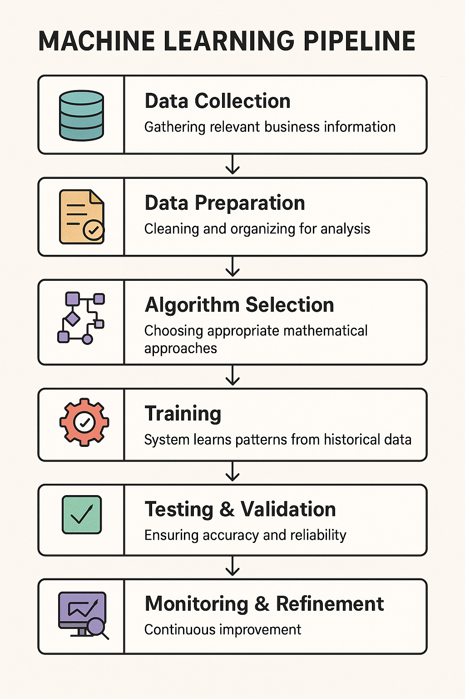

* This slide breaks down how machine learning actually works in a business context
* The process begins with data collection - you need relevant business information to learn from
* Data preparation is often the most time-consuming step - garbage in, garbage out applies here
* Algorithm selection means choosing the right mathematical approach for your specific problem
* The training phase is where the system learnns patterns from historical data
* Testing and validation ensure the system works reliably with new data
* Deployment means integrating the model into actual business workflows
* This isn’t “set and forget” - continuous monitoring and refinement is essential
* The Google Cloud case study shows how manufacturing applies these same principles
* The most important insight: data quality and relevance determine success more than algorithm sophistication
* Many businesses fail with AI because they underinvest in data preparation and quality

# Inside Modern AI: Understanding the “Attention” Revolution — In Simple Business Term

* **The Breakthrough**: A 2017 paper called *“Attention is All You Need”* changed how AI works.
* **What Changed**: AI systems can now *look at all the information at once* to find patterns and connections.
* **Business Analogy**: It’s like going from solving problems one step at a time to seeing the *whole strategy* at once.
* **Why It Matters**: AI can now understand context, relationships, and what’s most relevant — almost like a human.

### How Systems Like GPT Work

* **Pattern Spotting**: They learn by reading huge amounts of text (trillions of words).
* **Prediction Engine**: They guess what comes next in a sentence based on what came before.
* **Fine-Tuning**: They’re trained further to be more accurate and helpful for real-world use.
* I want to take a moment to demystify modern AI in simple business terms
* The systems you hear about - ChatGPT, Claude, Gemini - are based on a breakthrough from 2017
* This paper, “Attention is All You Need,” revolutionised AI by introducing the Transformer architecture
* Previous AI systems processed information sequentially - like reading a book one word at a time and constantly forgetting
* The breakthrough was the “attention mechanism” that lets AI instantly see connections across all information
* It’s like the difference between a junior employee who needs to check the manual for every decision versus an experienced executive who instantly connects relevant information
* These modern systems work in three main steps:
* First, they learn patterns from massive datasets - like reading every business document ever written
* Second, they function as prediction engines - you provide the beginning of a pattern, they predict the most appropriate continuation
* Third, they have an alignment layer - additional training to make them helpful, factual, and appropriate
* Understanding this helps business leaders see why these systems are fundamentally different from previous technologies
* They weren’t programmed with rules, they learned patterns - which explains both their remarkable capabilities and their limitations
* This isn’t just a technical detail - it has profound implications for how you implement AI in your organisation

# AI Limitations & Implementation Challenges

| Dimension | Key Limitations | Business Implications | Mitigation Strategies |
| --- | --- | --- | --- |
| **Technical Reality** | - Hallucinations and fabrications- Reasoning limits- Knowledge cutoffs- Black-box models | - Unreliable outputs- Can’t replace human judgment- Integration required- Opaque decisions | - Robust verification- Augment, don’t automate- Hybrid systems- Invest in explainable AI |
| **Organisational Challenges** | - Workforce skills gap- Legacy systems- Data issues- Exec buy-in gaps | - Slow adoption- Value trapped- High failure rates- ROI/expectation mismatch | - Build capabilities- Target high-value use cases- Fix data foundations- Value frameworks |
| **Ethical & Risk Dimensions** | - Bias & unfairness- Privacy/security risks- Regulatory complexity- Environmental impact | - Legal/reputation risks- Trust erosion- Compliance burdens- Sustainability concerns | - Responsible AI governance- Bias audits- Track regulations- Optimise for efficiency |

* While I’ve emphasised AI’s transformative potential, it’s equally important to understand its real limitations and implementation challenges.
* **Technical Limitations**:
  + Hallucinations remain a significant issue - AI systems confidently generate incorrect information that appears plausible, which creates verification challenges.
  + Current AI has fundamental reasoning limitations, especially with complex logical, mathematical, or causal reasoning tasks.
  + Knowledge cutoffs mean systems lack current information unless specifically integrated with real-time data sources.
  + The black-box nature of large models makes it difficult to understand why specific outputs are generated.
  + These limitations mean human verification remains essential, and we should focus on augmentation rather than full automation.
* **Organisational Challenges**:
  + The skills gap isn’t just technical - it includes the business capabilities needed to identify valuable use cases and manage implementation.
  + Integration with existing systems is often more challenging than the AI technology itself.
  + Data quality issues frequently derail AI initiatives - algorithms can’t overcome fundamentally flawed data.
  + McKinsey research shows that 80% of AI initiatives struggle to move beyond pilot phase due to these organisational barriers.
  + The practical approach is starting with targeted use cases that have clear value and building from there.
* **Ethical and Risk Dimensions**:
  + Bias amplification occurs when AI systems learn from and then magnify existing biases in training data.
  + Privacy concerns include both the data needed to train systems and the potential exposure of sensitive information in outputs.
  + Regulatory landscape is evolving rapidly, creating compliance uncertainty and potential legal exposure.
  + The environmental impact of large AI models is substantial - training a single large model can generate as much carbon as five cars over their lifetimes.
  + Organisations need proactive governance frameworks that address these concerns before they become problems.
* **Key Takeaway**:
  + Successful AI implementation requires clear-eyed recognition of these limitations.
  + The frameworks we’ve discussed provide structure for navigating these challenges.
  + Organisations that acknowledge and plan for these limitations ultimately achieve better results than those with unrealistic expectations.
  + This isn’t about dampening enthusiasm but ensuring that it’s channeled productively.

# Computer Vision in Business

**Enabling Machines to “See” for Business Value:**

* **How It Works:** Uses neural networks to identify objects, features, and patterns in images/video
* **Common Techniques:** Object detection, image classification, segmentation, tracking
* **Hardware Requirements:** Specialised processors (GPUs) for efficient processing
* **Deployment Options:** Edge devices, cloud processing, hybrid approaches

**Agricultural Application:** Smart spraying systems that reduce herbicide use by 80-96% by identifying individual weeds [Source: ABC News, “AI helps Aussie farmers target weeds,” 2024](https://www.abc.net.au/news/2024-10-12/artificial-intelligence-agriculture-boom-australia-rural/104450732)

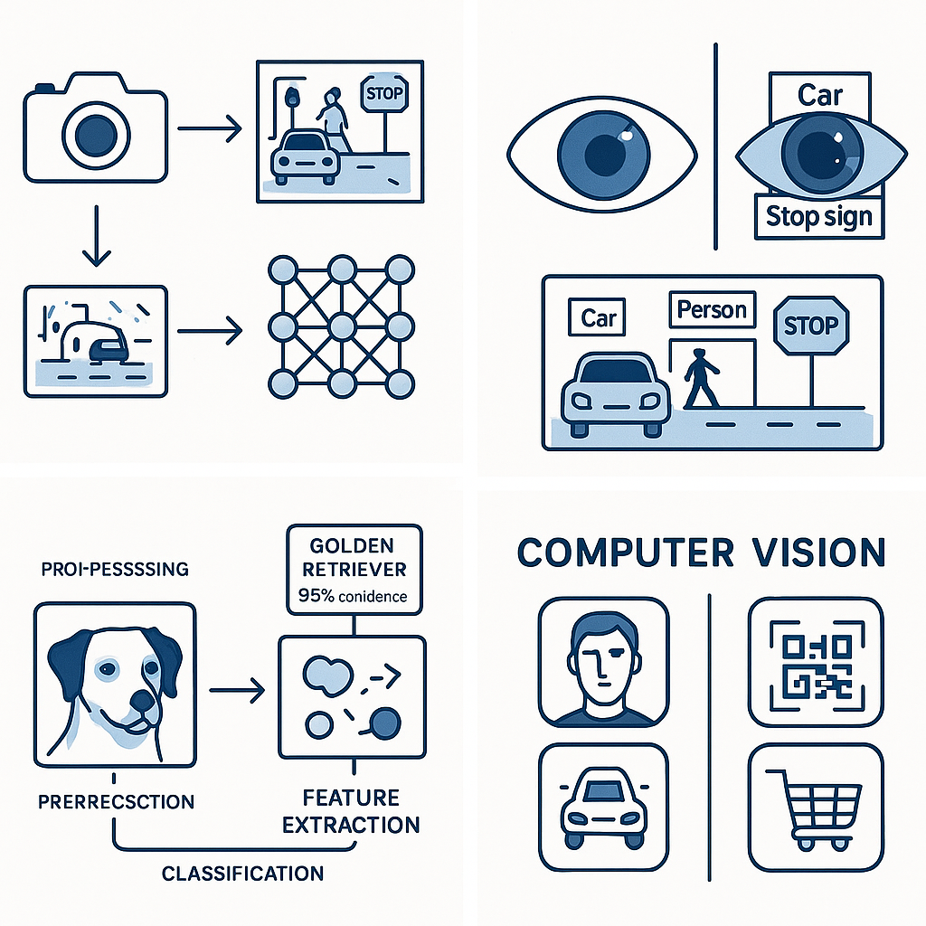

Computer Vision Example

* Computer vision enables machines to “see” and interpret visual information
* At its core, neural networks analyse pixel patterns to identify objects and features
* It works through techniques like object detection (finding things), classification (identifying what they are), segmentation (outlining objects precisely), and tracking (following objects over time)
* These systems typically require specialised hardware - regular computers struggle with this processing
* Deployment can happen on-device (edge), in the cloud, or in hybrid approaches
* The agricultural example is powerful - smart spraying systems use computer vision to only spray herbicide on weeds, not crops
* The 80-96% reduction in herbicide use is not just environmental but has massive cost implications
* This technology applies across industries - manufacturing quality control, retail analytics, security
* The Microsoft FarmBeats case study provides additional context on real-world applications
* The business value extends far beyond the technical capabilities - it transforms operations

# Natural Language Processing & LLMs

**Transforming How Businesses Work with Language:**

* **How NLP Works:** Analyses, understands and generates human language
* **Key Capabilities:** Sentiment analysis, information extraction, summarisation, translation
* **How LLMs Work:** Trained on massive text datasets to predict and generate human-like text
* **Business Applications:** Content generation, research assistance, customer service, decision support

**Agricultural Application:** Farm management planning tools that process complex regulations and research

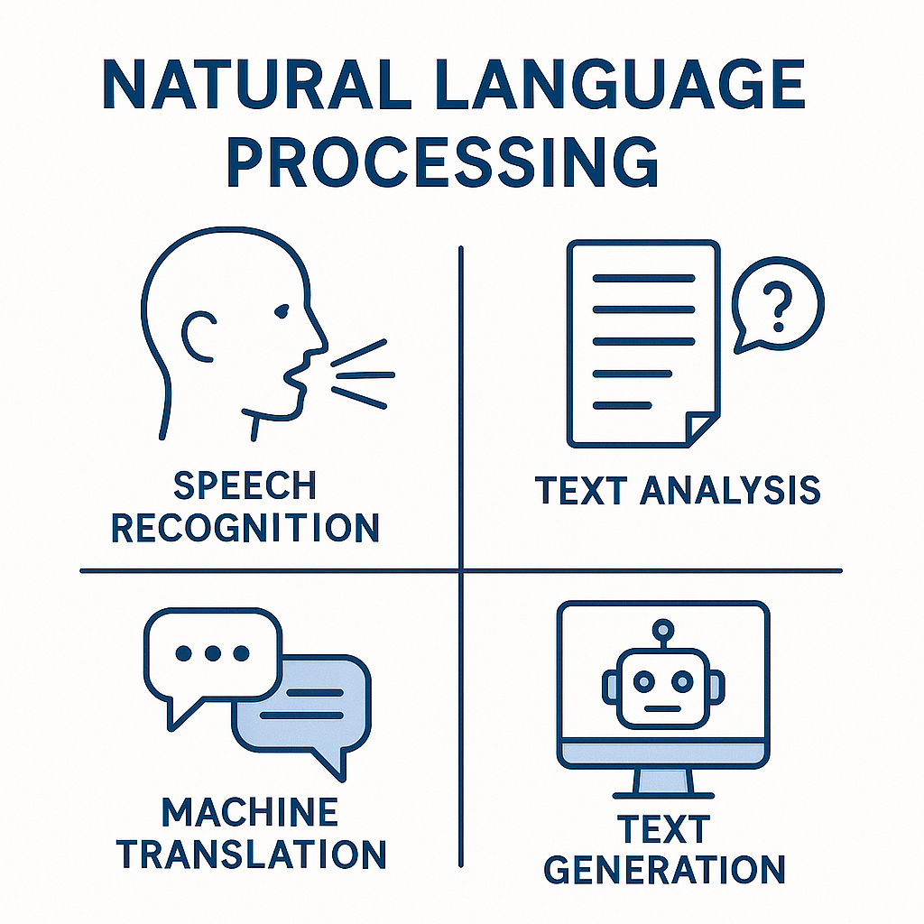

NLP Capabilities Diagram

* Natural Language Processing represents one of the most transformative AI capabilities for business
* At a basic level, NLP analyses and understands human language through complex pattern recognition
* Traditional capabilities include sentiment analysis (understanding emotion), information extraction (pulling key facts), summarisation, and translation
* Large Language Models like ChatGPT and Claude represent a quantum leap in capabilities
* LLMs work by being trained on massive text datasets to predict what text should come next
* This predictive capability allows them to generate remarkably human-like text and reasoning
* Business applications are extensive - content creation, research analysis, customer service, and decision support
* The agricultural example shows how LLMs can process complex regulations and research that would overwhelm humans
* This same capability applies to legal compliance, market research, and competitive intelligence in any industry
* The Deloitte guide provides implementation frameworks that transfer across business domains
* The key business insight is that LLMs are most valuable when integrating human expertise with AI capabilities

# AI Agents & Autonomous Systems

**Business Applications of Self-Directing AI:**

* **How They Work:** Systems that can sense, decide, and act with minimal human intervention
* **Key Components:** Perception modules, decision-making logic, action capabilities
* **Implementation Approaches:** Rules-based, learning-based, hybrid systems
* **Current Limitations:** Defined scope, supervision requirements, handling exceptions

**Agricultural Application:** Autonomous tractors and harvesters in “hands-free” farming operations

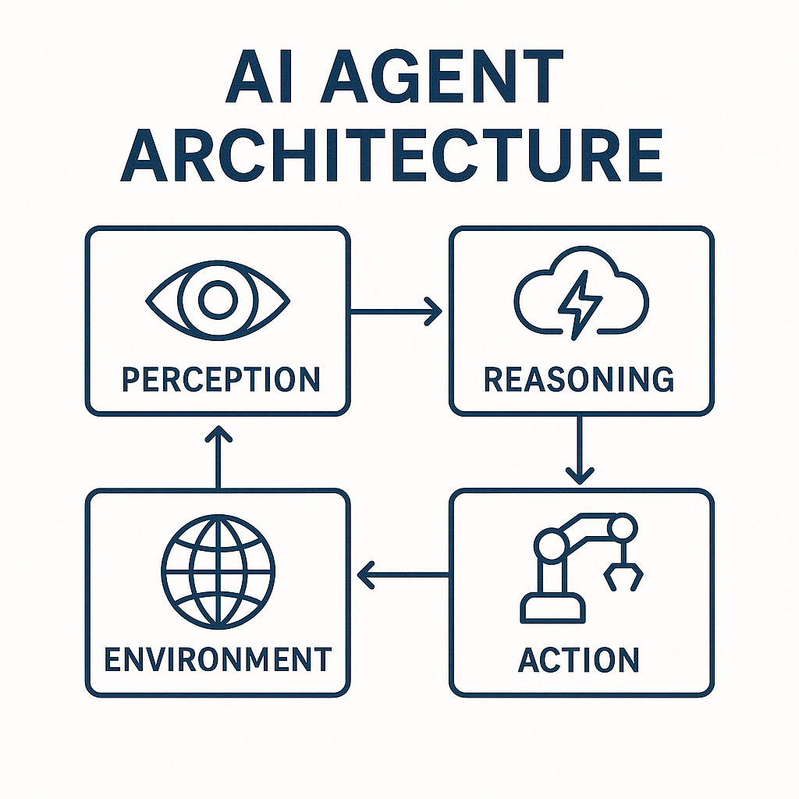

AI Agent Architecture

* AI agents represent the frontier of business applications - systems that can independently pursue objectives
* They work by combining three key capabilities: sensing (perceiving the environment), deciding (choosing actions), and acting (implementing decisions)
* The architecture typically includes perception modules that interpret the world, decision logic that determines actions, and capabilities to carry out those actions
* Implementation can be rules-based (following predefined instructions), learning-based (adapting through experience), or hybrid
* Current limitations are important to understand - most agents work within defined scopes, require supervision, and struggle with exceptional cases
* The agricultural example of autonomous tractors shows this in action - they can perform complex field operations with minimal supervision
* This same principle applies to autonomous systems in manufacturing, logistics, customer service, and financial operations
* The McKinsey case study provides a broader business perspective on implementation approaches
* The key insight is that autonomous systems aren’t about replacing humans but augmenting capabilities and freeing people for higher-value work
* The most successful implementations start with narrow, well-defined applications before expanding scope

# PART 2: BUSINESS INNOVATION FRAMEWORKS

* Now that we have a common understanding of AI technologies, let’s explore business innovation frameworks
* These frameworks help structure your approach to AI implementation
* The goal is to move from technology-driven implementation to business-driven transformation
* Each framework provides a different lens for approaching AI innovation
* I’ll show how these frameworks apply to agricultural examples, but they’re universally applicable

# The AI Transformation Matrix

**Four Quadrants of Business Impact:**

|  | Incremental | Transformational |
| --- | --- | --- |
| **Process Improvement** | Efficiency Gains | Business Process Reengineering |
| **Strategic Innovation** | New Capabilities | Business Model Reinvention |

**Agricultural Example:**

* Smart spraying (80-96% chemical reduction) started as efficiency gain but led to business model reinvention through sustainability certification premiums
* [Source: ABC News, “AI helps Aussie farmers target weeds,” 2024](https://www.abc.net.au/news/2024-10-12/artificial-intelligence-agriculture-boom-australia-rural/104450732)

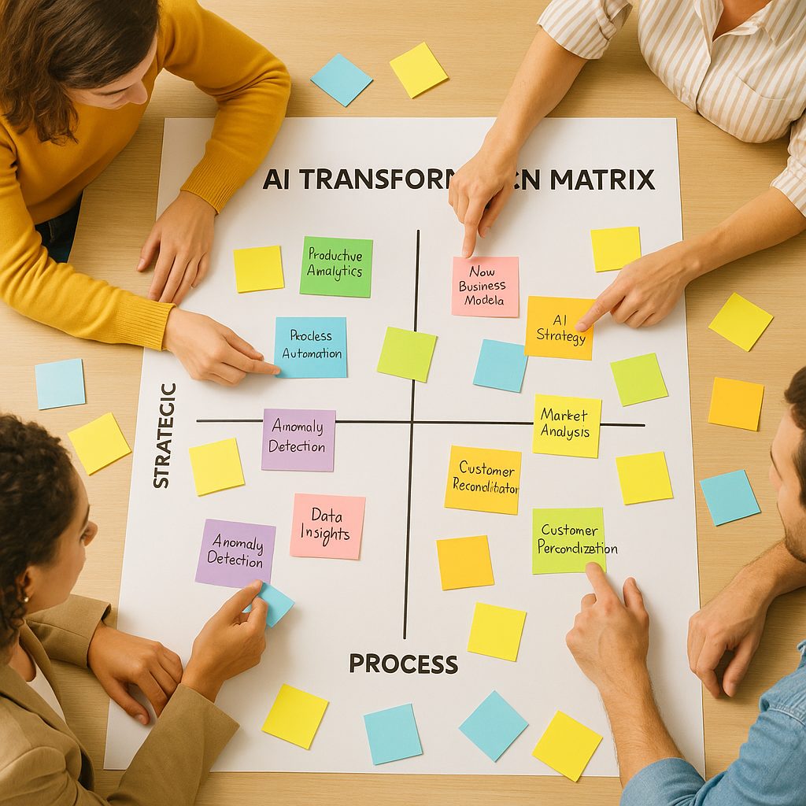

* The AI Transformation Matrix helps organisations map their AI initiatives based on impact type and scale
* The vertical axis represents the focus - are you improving processes or creating strategic innovation?
* The horisontal axis represents the magnitude - are the changes incremental or transformational?
* Most organisations start in the upper left - efficiency gains - which is appropriate but limited
* The smart spraying example shows the journey across this matrix
* It began as an efficiency play - reducing herbicide costs by 80-96% by only spraying actual weeds
* But it evolved into business model reinvention - enabling premium pricing through sustainability certification
* This pattern applies across industries - what starts as efficiency often leads to transformation
* The most successful organisations deliberately plan movement across this matrix over time
* The Deloitte framework provides additional context on implementing this approach
* This matrix helps executives communicate the strategic intent of AI initiatives and set appropriate expectations
* Ask yourself: Where do your current AI initiatives fall? Are you limiting yourself to the efficiency quadrant?

# The Data Value Pyramid

**Turning Information into Business Value:**

1. **Descriptive Analytics:** What happened? (Data collection)
2. **Diagnostic Analytics:** Why did it happen? (Data interpretation)
3. **Predictive Analytics:** What will happen? (Data forecasting)
4. **Prescriptive Analytics:** What should we do? (Data-driven decisions)
5. **Cognitive Analytics:** Self-optimising systems (Autonomous operations)

**Agricultural Example:** Livestock monitoring evolution from basic tracking → health predictions → autonomous intervention systems

* [Source: CSIRO, “Ceres Tag smart ear tags,” 2023](https://www.csiro.au/en/research/animals/livestock/ceres-tag)
* The Data Value Pyramid shows how organisations extract increasing value from their data
* Most organisations start at the bottom with descriptive analytics - simply understanding what happened
* Diagnostic analytics adds interpretation - why did these events occur?
* Predictive analytics moves into forecasting - what is likely to happen next?
* Prescriptive analytics recommends actions - what should we do about it?
* Cognitive analytics represents the frontier - systems that can optimise themselves
* The livestock monitoring example shows this evolution perfectly
* It began with basic GPS tracking of cattle (descriptive - where are they?)
* Advanced to health monitoring that could diagnose issues (why is this animal behaving differently?)
* Then to predictive systems that could forecast health problems before visible symptoms
* Now moving toward systems that can prescribe and even implement interventions
* This same progression applies to any data-driven business function
* The key insight: higher levels of the pyramid deliver exponentially more business value
* Most organisations get stuck at descriptive/diagnostic levels and never realise the full potential
* The Gartner model provides a framework for assessing your current maturity and planning advancement
* Where is your organisation on this pyramid? What would it take to move up one level?

# The Innovation Adoption Framework

**Five Business Implementation Phases:**

1. **Knowledge Building:** Understanding potential and possibilities
2. **Strategic Alignment:** Connecting AI to business objectives
3. **Capability Development:** Building human and technical resources
4. **Pilot Implementation:** Testing and proving value
5. **Organisational Transformation:** Scaling and integrating across business

**Agricultural Example:** How Digital Agriculture Services (DAS) progressed through these phases when implementing their crop forecasting system - [Additional coverage: IT Brief article](https://itbrief.com.au/story/das-uses-ai-to-reveal-varying-australian-crop-yields)

* The Innovation Adoption Framework provides a roadmap for implementing AI in organisations
* Phase 1 is Knowledge Building - understanding what’s possible before making commitments
* Phase 2 is Strategic Alignment - connecting AI initiatives to specific business objectives
* Phase 3 is Capability Development - building or acquiring the needed skills and technologies
* Phase 4 is Pilot Implementation - testing in controlled environments to demonstrate value
* Phase 5 is Organisational Transformation - scaling successful approaches across the business
* The Digital Agriculture Services example illustrates this progression
* They began by building knowledge about how satellite imagery and ML could predict crop yields
* They aligned this with strategic business needs in agricultural insurance and investment
* They developed capabilities by building data science teams and satellite imagery processing
* Their pilot implementations tested predictions against ground-truth data in specific regions
* Now they’re transforming the agricultural intelligence landscape at organisational scale
* This framework applies to any significant innovation initiative, not just AI
* The key insight: skipping phases often leads to implementation failure
* Many organisations jump straight to pilots without strategic alignment or capability building
* The KPMG framework provides additional detail on implementing each phase
* What phase is your organisation currently in? Are you trying to skip essential steps?

# The AI Investment Model

**Calculating Return on AI Investment:**

* **Cost Considerations:** Implementation, integration, training, maintenance
* **Value Categories:** Efficiency gains, new capabilities, risk reduction, market differentiation
* **Measuring Success:** KPIs, benchmarks, and value capture mechanisms
* **Timeline Expectations:** Short-term wins vs. long-term transformation

**Agricultural Example:** AgBot II autonomous weeding robot’s ROI calculation model and payback period analysis

* [Source: Queensland University of Technology, “AgBot II Robot for Farm Weed Management”](https://research.qut.edu.au/qcr/Projects/agbot-ii-robotic-site-specific-crop-and-weed-management-tool/)
* The AI Investment Model provides a framework for calculating the business value of AI initiatives
* Cost considerations include not just implementation but integration with existing systems, staff training, and ongoing maintenance
* Value categories are diverse - efficiency gains are most obvious, but new capabilities, risk reduction, and market differentiation often deliver greater value
* Measuring success requires specific KPIs tailored to your business objectives
* Timeline expectations are crucial - some benefits appear quickly while transformational value takes longer
* The AgBot II example demonstrates this comprehensive approach to ROI calculation
* Initial costs included development, manufacturing, and implementation
* Value categories included reduced herbicide costs, labor savings, and yield improvements
* Their measurement approach compared traditional methods to autonomous operations
* Timeline expectations recognised short-term operational savings and long-term transformation of weed management
* The projected AU$1.3 billion national impact shows the scaling potential
* This same model applies to AI investments in any business domain
* The key insight: comprehensive ROI calculations require looking beyond obvious cost savings
* Most organisations underestimate both costs (especially integration) and benefits (especially strategic value)
* The HBR article provides additional frameworks for calculating generative AI ROI
* How comprehensive is your current approach to AI investment calculations?

# PART 3: IMPLEMENTING AI INNOVATION STRATEGIES

* Now let’s move from frameworks and case studies to specific implementation strategies
* These strategies provide practical approaches to applying the frameworks we’ve discussed
* Each strategy addresses a different aspect of successful AI implementation
* Together, they form a comprehensive toolkit for business leaders
* Again, while our examples are agricultural, these strategies apply universally

# Strategy 1: The Business Model Canvas for AI Integration

**Key Components:**

* **Problem-Solution Fit:** Identify specific business challenges AI can address
* **Value Proposition Canvas:** Define clear value added through AI
* **Resource Assessment:** Gap analysis of capabilities needed
* **Cost-Benefit Structure:** Comprehensive ROI model

**Agricultural Application:** How Wagga Wagga “hands-free” farm used this canvas to develop their autonomous farming business case

**Additional Coverage:** [ABC News: Automated Farm](https://www.abc.net.au/news/rural/2021-05-27/automated-farm-to-use-robots-and-artificial-intelligence/100169302)

* The Business Model Canvas provides a structured approach to integrating AI into business models
* Problem-Solution Fit ensures you’re addressing actual business challenges, not just deploying technology
* The Value Proposition Canvas helps articulate exactly what value AI adds for customers and the business
* Resource Assessment identifies capability gaps in technology, data, expertise, and infrastructure
* Cost-Benefit Structure creates a comprehensive model of investment and returns
* The Wagga Wagga “hands-free” farm applied this approach to autonomous farming
* They identified specific problems - labor shortages, precision limitations, and management complexity
* Their value proposition focused on higher yields, reduced inputs, and consistent quality
* Their resource assessment identified gaps in technical infrastructure and staff capabilities
* Their cost-benefit structure modeled initial investment against multi-year productivity gains
* This systematic approach helped secure funding and stakeholder support
* The same canvas framework applies to AI integration in any industry
* The key insight: successful AI implementation begins with business model clarity, not technology selection
* The Strategyser reference provides templates and examples for applying this canvas
* How might this canvas help structure your organisation’s approach to AI integration?

# Strategy 2: The MVP (Minimum Viable Product) Approach

**Framework Elements:**

* **Scope Definition:** Select high-impact, low-complexity starting point
* **Success Metrics:** Define clear KPIs tied to business outcomes
* **Feedback Loops:** Structured learning mechanisms
* **Scaling Plan:** Path from pilot to enterprise implementation

**Agricultural Application:** CQUniversity’s staged approach to weed-targeting drone deployment

* [Source: CQUniversity, “Autonomous weed-targeting AI drones a sky-high success”](https://www.cqu.edu.au/news/1202013/autonomous-weed-targeting-ai-drones-a-sky-high-success)

**Framework Reference:** [Lean Startup Methodology](https://hbr.org/2013/05/why-the-lean-start-up-changes-everything)

* The MVP (Minimum Viable Product) Approach applies lean startup methodology to AI implementation
* Scope Definition means selecting a narrow, high-impact use case for initial implementation
* Success Metrics establish clear, measurable KPIs tied directly to business outcomes
* Feedback Loops create structured mechanisms for learning and adaptation
* The Scaling Plan maps the path from successful pilot to enterprise-wide implementation
* CQUniversity applied this approach to their weed-targeting drone project
* They defined a narrow initial scope - identifying a single weed species in sorghum crops
* Their success metrics included detection accuracy, reduction in herbicide use, and time savings
* They established feedback loops through field testing and farmer interviews
* Their scaling plan expanded to additional weed species, crop types, and geographic regions
* This staged approach reduced risk while demonstrating value at each step
* The same MVP methodology applies to AI implementation in any domain
* The key insight: starting small but strategically creates momentum and builds credibility
* Many organisations fail by attempting too much too soon without proving value
* The Lean Startup reference provides additional context on applying this methodology
* Could your organisation benefit from a more focused MVP approach to AI implementation?

# Strategy 3: The Capability Building Roadmap

**Framework Components:**

* **Skills Assessment:** Current vs. required capabilities
* **Build-Buy-Partner Decisions:** Sourcing strategy for AI capabilities
* **Training and Development Plan:** Upskilling existing workforce
* **Organisational Structure Evolution:** New roles and responsibilities

**Agricultural Application:** How Northern Territory cattle stations developed internal capabilities for GPS collar data analysis

* [Source: CSIRO’s livestock monitoring research](https://www.csiro.au/en/research/animals/livestock/ceres-tag)
* The Capability Building Roadmap addresses the human and organisational aspects of AI implementation
* Skills Assessment maps current capabilities against those required for AI transformation
* Build-Buy-Partner Decisions determine whether to develop internal capabilities, acquire them, or partner
* Training and Development Plans establish how to upskill the existing workforce
* Organisational Structure Evolution identifies new roles, reporting relationships, and governance models
* The Northern Territory cattle stations example demonstrates this approach
* They began by assessing existing skills against those needed for GPS collar data analysis
* They decided to build core analytical capabilities internally while partnering for technical infrastructure
* They developed training programs for station managers to interpret movement patterns
* They evolved their organisational structure to include data analysts and GIS specialists
* This capability-focused approach ensured sustainable implementation beyond initial deployment
* The same roadmap applies to building AI capabilities in any organisation
* The key insight: technology implementation without capability building leads to dependence and limited value
* Many organisations underinvest in the human and organisational dimensions of AI
* The Deloitte framework provides additional context on capability development approaches
* How comprehensive is your organisation’s capability building roadmap for AI?

# Strategy 4: The Data Strategy Blueprint

**Framework Elements:**

* **Data Inventory:** Assessing available and needed data sources
* **Data Quality Framework:** Ensuring reliable inputs for AI systems
* **Data Governance Model:** Managing ownership and access rights
* **Privacy and Ethics Guidelines:** Responsible data practices

**Agricultural Application:** Australian Farm Data Code implementation by agtech providers

* [Source: National Farmers’ Federation (NFF)](https://nff.org.au/programs/australian-farm-data-code/)

**Framework Reference:** [MIT Sloan Data Strategy Framework](https://sloanreview.mit.edu/article/designing-and-developing-analytics-based-data-products/)

* The Data Strategy Blueprint addresses the foundation of effective AI implementation
* Data Inventory assesses what data you have, what you need, and identifies gaps
* The Data Quality Framework ensures reliable, consistent inputs for AI systems
* Data Governance Models manage ownership, access rights, and usage policies
* Privacy and Ethics Guidelines establish responsible practices for data collection and use
* The Australian Farm Data Code implementation demonstrates this approach
* Agricultural technology providers created comprehensive inventories of farm data sources
* They established quality standards for data collection and processing
* They implemented governance models that preserved farmer ownership of data
* They developed ethical guidelines for responsible data use and sharing
* This systematic approach built trust while enabling innovation
* The same blueprint applies to data strategy in any industry
* The key insight: data strategy must precede AI implementation for sustainable success
* Many organisations jump to AI implementation without addressing fundamental data issues
* The MIT Sloan framework provides additional context on developing data strategies
* How comprehensive is your organisation’s data strategy? Is it an afterthought or a foundation?

# PART 4: ETHICAL CONSIDERATIONS IN AI BUSINESS MODELS

* Now let’s address the ethical dimensions of AI implementation
* This isn’t just about doing the right thing - though that matters
* It’s also about managing risk, building trust, and ensuring sustainable value
* These ethical frameworks should be integrated into business strategy from the beginning
* They provide guardrails that enable rather than constrain innovation

# The Responsible Innovation Framework

**Core Business Principles:**

* **Transparency:** Explainable AI for stakeholder trust
* **Accountability:** Clear responsibility for AI systems
* **Fairness:** Equitable access and benefits across business scales
* **Sustainability:** Long-term environmental and social impacts

**Agricultural Application:** Ethical considerations in autonomous farming systems

* [Related Resource: Australia’s AI Ethics Framework](https://www.industry.gov.au/publications/australias-artificial-intelligence-ethics-framework)

**Framework Reference:** [IEEE Ethically Aligned Design](https://standards.ieee.org/industry-connections/ec/autonomous-systems/)

* The Responsible Innovation Framework establishes principles for ethical AI implementation
* Transparency means making AI systems explainable to build stakeholder trust
* Accountability establishes clear responsibility for AI decisions and actions
* Fairness ensures equitable access and benefits across different organisational scales
* Sustainability addresses long-term environmental and social impacts
* The autonomous farming systems example demonstrates these principles in action
* Transparency in how autonomous systems make decisions about field operations
* Accountability through clear human oversight and intervention capabilities
* Fairness considerations for accessibility to farms of different sises and resource levels
* Sustainability focus on environmental impacts and rural community effects
* These principles helped guide implementation choices and system design
* The same framework applies to responsible AI innovation in any industry
* The key insight: ethical considerations should be built in from the beginning, not added later
* Organisations that integrate ethics into design avoid costly redesigns and reputation damage
* The IEEE framework provides additional guidance on ethically aligned design
* How are ethical considerations integrated into your organisation’s AI strategy?

# The Technology Democratisation Model

**Business Framework for Inclusive Innovation:**

* **Access Mechanisms:** How smaller businesses can leverage AI
* **Capability Building:** Community-based knowledge sharing
* **Cooperative Models:** Shared resources and infrastructure
* **Policy Considerations:** Supporting ecosystem development

**Agricultural Application:** Cooperative AI implementation models for family farms - [Case Study: Birchip Cropping Group’s shared technology model](https://www.bcg.org.au/research/digital-agriculture/)

* The Technology Democratisation Model addresses how to make AI accessible across organisation sises
* Access Mechanisms are approaches that enable smaller businesses to leverage advanced AI
* Capability Building focuses on community-based knowledge sharing and skill development
* Cooperative Models enable shared resources and infrastructure to distribute costs
* Policy Considerations address ecosystem development to support inclusive innovation
* The family farm cooperative example demonstrates this approach
* Access mechanisms included subscription-based AI services with minimal upfront investment
* Capability building happened through farmer-to-farmer knowledge networks
* Cooperative models shared equipment costs and data infrastructure
* Policy advocacy influenced research funding and connectivity infrastructure
* This democratic approach ensured benefits weren’t limited to the largest players
* The same model applies to technology democratisation in any industry
* The key insight: inclusive innovation approaches strengthen entire ecosystems
* Organisations that support democratisation often benefit from network effects and ecosystem growth
* The WEF framework provides additional context on inclusive technology development
* How might your organisation contribute to more democratic access to AI capabilities?

# PART 5: FUTURE BUSINESS HORIsONS

* Let’s look at how to strategically plan for future AI developments
* The goal is to build a balanced portfolio of innovation initiatives
* This helps organisations manage risk while capturing emerging opportunities
* The Three Horisons model provides a framework for this strategic planning
* It’s about managing the present while building the future

# The Three Horisons of AI Innovation

**Business Planning Framework:**

* **Horison 1 (Next 2 Years):** Extending and defending core business
  + Implementing proven AI technologies for immediate gains
  + Example: Smartphone-based decision support tools
  + [Source: iGrowNews, “Australian Farmers Embrace AgTech,” 2024](https://igrownews.com/australian-farmers-embrace-agtech-overcoming-key-barriers/)
* **Horison 2 (2-5 Years):** Building emerging opportunities
  + Investing in developing capabilities and new business models
  + Example: Integrated “smart farm” management systems
* **Horison 3 (5-10 Years):** Creating viable options for future business
  + Exploring breakthrough possibilities and industry transformation
  + Example: Autonomous farms with minimal human intervention
  + [Source: Food Agility CRC Future Vision](https://www.foodagility.com/pillar/global-digital-farm)

**Key Business Insight:** Balanced investment portfolio across all three horisons is essential for sustainable innovation

* The Three Horisons model provides a framework for balanced innovation planning
* Horison 1 focuses on the next 2 years - extending and defending the core business
* This includes implementing proven AI technologies for immediate business gains
* In agriculture, this means smartphone-based decision support tools already being adopted
* Horison 2 looks at the 2-5 year timeframe - building emerging opportunities
* This involves developing capabilities and new business models with growing evidence
* The integrated “smart farm” systems represent this horison - proven in concept but not yet mainstream
* Horison 3 addresses the 5-10 year future - creating viable options for future business
* This explores breakthrough possibilities that could transform industries
* Fully autonomous farming operations exemplify this horison - technically possible but not yet practical
* The key insight is that organisations need a balanced portfolio across all three horisons
* Most organisations overinvest in Horison 1 and underinvest in Horisons 2 and 3
* This leaves them vulnerable to disruption and missing future opportunities
* The McKinsey model provides additional guidance on portfolio allocation
* How balanced is your organisation’s innovation portfolio across these three horisons?

# AI Next 2 years

| Time Horizon | Technical Evolution | Business Impact | Society & Governance |
| --- | --- | --- | --- |
| **Next 2 Years**(2025-2027)*Expansion & Consolidation* | • Advanced multimodal models• Smaller, efficient models for edge devices• Domain-specialised AI systems• Early agentic AI | • Productivity gains in knowledge work• Integration into enterprise workflows• Software development disruption• Focus on ROI and practical applications | • First comprehensive AI regulations• Growing emphasis on transparency• AI literacy becoming essential• Educational adaptation |

* This timeline provides a strategic perspective on AI evolution over the next decade, organised using the Three Horizons framework we discussed earlier.
* **For the Next 2 Years (2025-2027) - “Expansion & Consolidation”**:
  + Technically, we’re seeing multimodal models becoming standard, not just handling text but processing and generating across multiple formats simultaneously.
  + The business focus is pragmatic - organisations are prioritising measurable ROI and practical applications rather than experimental use cases.
  + The key development in governance is the implementation of first-generation comprehensive regulations, similar to what we’re seeing with the EU AI Act but with global variations.
  + This period represents enhancement of current business models rather than fundamental transformation.

# AI Next 2-5 yrs

| Time Horizon | Technical Evolution | Business Impact | Society & Governance |
| --- | --- | --- | --- |
| **2-5 Years**(2027-2030)*Systems Integration & Transformation* | • AI agents with memory and reasoning• Personalised AI assistants• AI-native applications• Next-gen hardware deployment | • “Co-pilot for everything” reality• Major industry disruption• Job transformation• New AI-enabled business models | • Mature international standards• Ethical governance frameworks• AI accelerating scientific discovery• Workforce reskilling priority |

* **For the Medium Term (2027-2030) - “Systems Integration & Transformation”**:
  + The technical evolution moves toward truly agentic systems - AI that can reason across context, maintain memory, and operate with limited autonomy.
  + Business impact shifts from enhancing current processes to transforming them - we’ll see “co-pilots” for virtually every knowledge work domain.
  + This will drive significant job transformation - not primarily elimination but redefinition of roles around AI collaboration.
  + Governance frameworks mature from reactive to proactive, with established international standards similar to what we’ve seen with data privacy.

# AI Next 5-10 yrs

| Time Horizon | Technical Evolution | Business Impact | Society & Governance |
| --- | --- | --- | --- |
| **5-10 Years**(2030-2035)*AI-Native Society & Reinvention* | • General-purpose AI systems• Potential AGI emergence• Quantum-AI synergies• Advanced human-AI interfaces | • Economic structural changes• High-level cognitive automation• New career categories• AI as critical infrastructure | • Global AI governance treaties• Redefined creativity concepts• Existential risk management• Philosophical reassessment |

* **For the Long Term (2030-2035) - “AI-Native Society & Reinvention”**:
  + While I’ve included potential AGI emergence, this remains speculative - what’s more certain is the development of increasingly general-purpose systems.
  + The business landscape undergoes structural changes as AI becomes critical infrastructure - similar to how the internet transformed from advantage to necessity.
  + We’ll likely see entirely new career categories emerge rather than just automation of existing ones.
  + Governance shifts to treaty-level international frameworks addressing existential concerns.
  + This period also brings deeper philosophical questions about human-AI relationships and creativity.
* **Key Strategic Implications**:
  + Organisations need balanced investment portfolios across all three horizons.
  + Near-term focus should be on practical applications with measurable ROI.
  + Medium-term planning should involve business model innovation and workforce transformation.
  + Long-term vision should consider fundamental shifts in how value is created and delivered.
  + Each industry will experience this timeline differently, with some sectors transforming faster than others.
* **For Your Organisation**:
  + Consider where your current AI initiatives fall on this timeline.
  + Are you overly focused on Horizon 1 at the expense of preparing for Horizons 2 and 3?
  + Have you considered the talent and capability implications of each horizon?
  + How might your competitive landscape change as AI evolves across these timeframes?

# Conclusion: Your Strategic AI Innovation Journey

* AI implementation is fundamentally a business transformation opportunity
* Strategic frameworks transform technology potential into business value
* The path from concept to implementation requires structured approaches
* Your competitive advantage lies in how you implement, not just what you implement

“The organisations that thrive won’t merely adopt AI technologies—they’ll master the frameworks that transform those technologies into strategic advantage.”

* As we conclude our exploration of AI-driven business innovation, I want to emphasise the tremendous opportunity ahead
* Throughout this masterclass, we’ve seen that successful AI implementation isn’t primarily a technical challenge—it’s a strategic business transformation opportunity
* The frameworks we’ve explored today provide the architecture for that transformation, regardless of your industry or organisation size
* While we’ve drawn examples from agriculture for their clarity and impact, these same frameworks apply whether you’re in manufacturing, healthcare, finance, retail, or any other sector
* The agricultural examples demonstrate how the same technology can yield dramatically different outcomes based on implementation approach
* I encourage you to reflect on which frameworks resonate most with your specific business challenges:
  + Perhaps the AI Transformation Matrix helps you map your current initiatives
  + Or the Three Horizons model provides structure for your innovation portfolio
  + Or the Data Value Pyramid helps articulate your analytics progression
* What makes these frameworks powerful is their ability to create organisational alignment, focus resources, and build sustainable capability
* Organisations with identical access to AI technologies achieve vastly different results based on how strategically they implement
* As you consider your next steps:
  + Which framework will you apply first in your organisation?
  + What immediate opportunity do you see to create value?
  + How might you build a more structured approach to AI innovation?
* The future belongs to organisations that master not just the technology but the strategic frameworks that guide implementation
* I’m excited to see the innovation journeys you’ll embark on, and I welcome your questions about applying these frameworks to your specific challenges
* Thank you for your engagement today

# Thank You

* **Dr. Michael Borck**
* Curtin Business School
* michael.borck@curtin.edu.au
* [linkedin.com/in/michael-borck](https://linkedin.com/in/michael-borck)

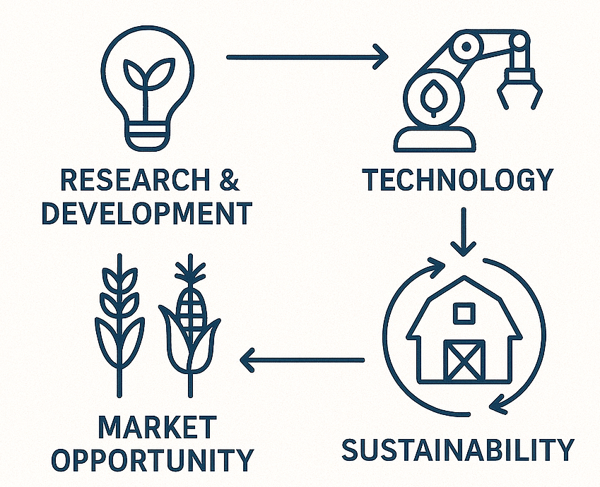

Business innovation diagram with agricultural elements

* Please feel free to reach out after the masterclass
* I’m happy to discuss specific business innovation challenges
* Or to provide additional frameworks relevant to your industry
* Connect with me on LinkedIn for ongoing insights on AI business innovation
* I regularly share case studies and implementation frameworks there
* Thank you again for your participation and engagement today
* Thank you all for your attention and engagement
* I hope you leave with practical frameworks you can apply immediately
* Remember that successful AI implementation is about business innovation first, technology second
* Agriculture provides compelling examples, but these frameworks are universally applicable
* I look forward to hearing how you apply these approaches in your organisations
* Safe travels and best wishes for your AI innovation journeys